Application of Big Data in GE

1. GE Aviation's Flight Analytics platform ( implemented in Brazil)
GE Big Data Cuts Airlines’ Carbon Emissions, Operational Costs
To evaluate the efficiency of historical flight operations, identify areas for improvement, and quantify the potential efficiency gains.

Benefit : An efficient, cost-saving network within the first year.
http://www.gereports.com/easing-brazils-jammed-skies/

2. Megabytes for Megawatts: How GE’s Big Data System Helped Slash Smelter’s Power Bill (implemented in 2012)
Six years ago, with Chinese competition growing, Dubai Aluminium (DUBAL) asked GE to cut the plant’s power appetite.
New System was developed by GE workers in Florida and customized by a team of engineers in Hyderabad, India, makes the DUBAL smelter 22 percent more efficient, cuts nitrogen oxide by nearly a third, and saves the company $4 million in annual fuel costs.
http://www.gereports.com/megabytes-for-megawatts/

3. GE uses big data to power machine services business
- big data analytics to predict maintenance needs.
(used in transportation, energy business)
http://www.computerweekly.com/news/2240176248/GE-uses-big-data-to-power-machine-services-business

GE uses NoSQL and Hadoop.
developed own database for time series analysis. GE is also working with Microsoft Azure and Amazon Web Services to investigate how to offload processing to the cloud.

4. Industrial Internet
New GE technology merges big iron with big data to create brilliant machines. This convergence of machine and intelligent data is known as the Industrial Internet.

GE’s new Hadoop-based software is targeted at the “industrial Internet.”
Aviation, health care, energy, transportation, and manufacturing all can benefit from real-time insight and analytics.

150 billion dollars in waste that can be eliminated by the Industrial Internet.

Partnerships with Pivotal, Amazon, and Accenture
Pivotal is the recent high-profile spin-off of EMC and VMWare that got $105 million funding from GE in late April 2013.
Pivotal will use its Cloud Foundry platform and Hadoop-based tech to support GE.

Amazon will be the first cloud provider on which GE will deploy its industrial Internet platform.
Accenture and GE will jointly develop new tech and analytics apps that leverage big data.

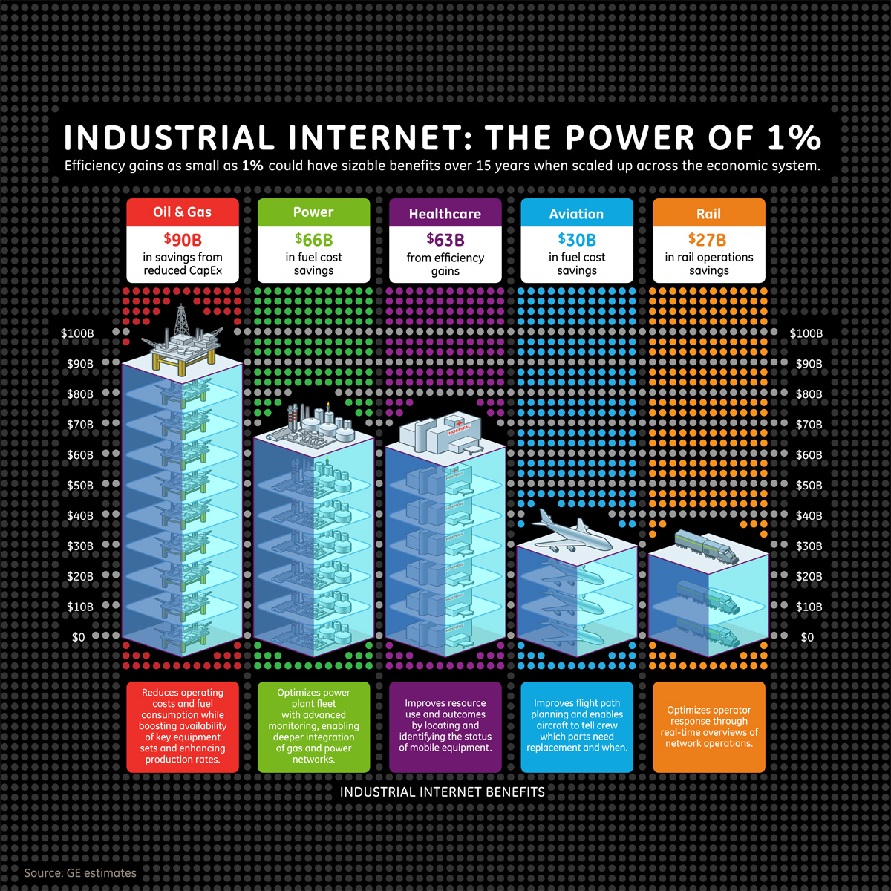
http://www.ge.com/stories/industrial-internet
http://medcitynews.com/2013/06/ges-big-data-software-targets-healthcare-other-industries/

Big Data Case Study: How GE is Building Big Data, Software and Analytics Capabilities for an “Industrial Internet
http://sites.tcs.com/big-data-study/ge-big-data-case-study/

Competitor for GE (Industrial Internet)
http://slashdot.org/topic/bi/big-datas-next-big-battle-ibm-versus-ge/
http://wikibon.org/blog/with-pivotal-investment-ge-takes-on-ibm-to-win-the-industrial-internet/

5. GE Aviation is pairing big data with additive manufacturing to 3D print parts for the LEAP engine.

Big Data Meets 3-D Printing: Big Data to Monitor Laser-Printed Jet Engine Parts
Big data tech will collect and analyze 3-D printing data to spot potential trouble during manufacturing.

http://www.gereports.com/big-data-meets-3-d-printing/

more in Aviation – http://www.gereports.com/now-departing/

6. How big data is changing the oil & gas industry ( new market)

The advent of the “digital oil field” helps produce cost-effective energy while addressing safety and environmental concerns.

The oil and gas industry has an opportunity to capitalize on “big data” analytics solutions. Now the oil and gas industry must educate “big data” on the types of data the industry captures in order to utilize the existing data in faster, smarter ways that focus on helping find and produce more hydrocarbons, at lower costs in economically sound and environmentally friendly ways.

http://www.analytics-magazine.org/november-december-2011/695-how-big-data-is-changing-the-oil-a-gas-industry

